IT SUPPORT PERFORMANCE
AND TICKET ANALYSIS

Driving IT Service Excellence: A Data-Driven Insights into IT Operations, Agent Performance, and Customer Satisfaction


TOOLS USED:
- Microsoft Excel
- Data Cleaning
- Data Visualization
- Pivot tables

DATA: IT Tickets and Agent Summary

PROJECT: Newton School Data Analytics Spreadsheet Project

PREPARED BY: Sumit Suprabhat Bhatia

SUBMITTED TO: Newton School

OBJECTIVE QUESTIONS

Question 1: What is the total no. of attributes present in the data?
Solution:

Final Answer:
Total no. of attributes present in the data: 22 Attributes
- Tickets Sheet – 14
- IT Agents Sheet – 8

Approach:
A small table is created to identify the attributes in both the datasets [ Tickets (Cleaned Data) and IT Agents (Cleaned Data)] given after cleaning the data. Formulas used are: =COUNTA(A1:N1) for Tickets; =COUNTA('IT Agents (Cleaned Data)'!A1:H1) for IT Agents and =SUM(U5:U6) to add the count of both sheets.

Charts & Tables:
- Table Name:
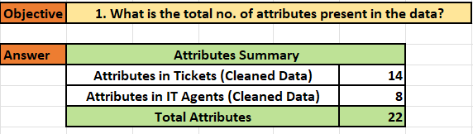
Attributes Summary

- Description:
This table represents the total number of attributes presents in the data.

Question 2: Which columns have inconsistent or missing values, and what is the count of such values?
Solution:

Final Answer:
- There are no missing values in the dataset.
- However, there were many spelling inconsistency in the dataset which were corrected:
Worksheet | Column | Incorrect | Correct | Total records
Tickets | Severity | Unclasified | Unclassified | 356
 | Severity | Mayor | Major | 4836
 | Priority | Unassiged | Unassigned | 29410
 | Column Header | Fecha(spanish) | Date(English) | 1
IT Agents | Full Name | JesusGrajeda | Jeses Grajeda | 1
 | Full Name | EstuardoTorres | Estuardo Torres | 1

Approach:
- Missing values were checked using two methods:
- Home → Editing → Find & Select → Go to Special → Blanks
- Using COUNTBLANK function, for Tickets =COUNTBLANK(A1:N97499); for IT Agents =COUNTBLANK('IT Agents (Cleaned Data)'!A1:I51)
- Spellings were corrected using:
Review → Proofing → Spelling
Incorrect and corrected spellings are mentioned in the table given in the final answer along with the total records.

Charts & Tables:
- Table / Chart Name:
Summary for Data Cleaning
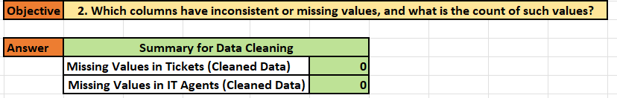
- Description:
The purpose of cleaning the data is to use correct and relevant data for further processing and analysis.

Question 3: What is the average daily ticket volume over time?
Solution:

Final Answer:
The average daily ticket volume over time is 53.37 tickets per day.

Approach:
A pivot table is created with
- Rows → Date
- Values → Count of ID Ticket
Daily ticket count was averaged using:
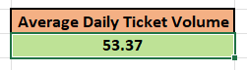
=ROUND(AVERAGE(D7:D1833),2)

Charts & Table:
- Table / Chart Name:
Daily Ticket Volume
- Description:
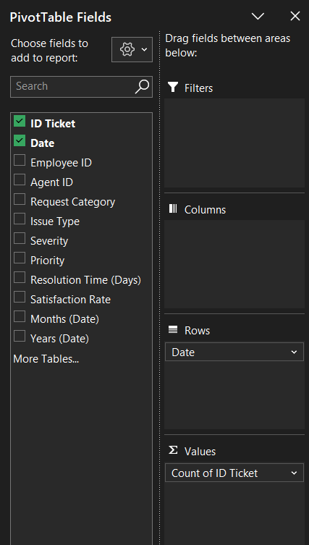
This table represents count of IT Ticket on daily basis.
Question 4: What is the distribution of ticket categories (e.g., Login Access, System, Software)?
Solution:

Final Answer:
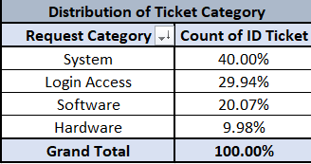
Approach:
A pivot table was created using:
- Rows → Request category
- Values → Count of ID Ticket
Under value field settings for ‘Count of ID Ticket’, show value as is changed from no calculation to % of grand total to have the final percentage of ID Ticket count.
Based on the pivot table created 2 charts are prepared:
- Column chart (2) Pie chart

Charts & Tables:
- Table / Chart Name:
Distribution of Ticket Category
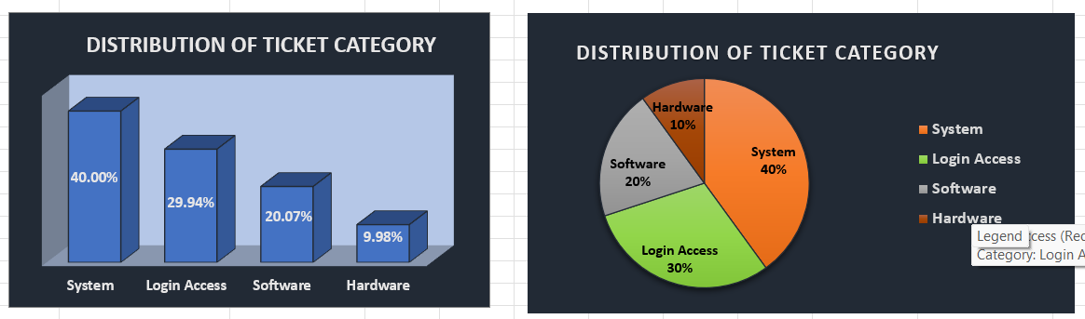
- Description:
Displays ticket distribution across request categories.

Question 5: How many tickets has each agent handled?
Solution:

Final Answer:
Ticket handling by each agent is displayed in the pivot table.

Approach:
A pivot table is created using
- Rows - Agent ID
- Values - Count of ID Ticket
Count of ID Ticket data is sorted from largest to smallest showing the top performing agent (Aurelio Tanori with 2027 tickets).
Based on the ticket per agent pivot table, a column chart is created (image shown).

Charts & Tables:
- Table / Chart Name:
Tickets per Agent
- Description:
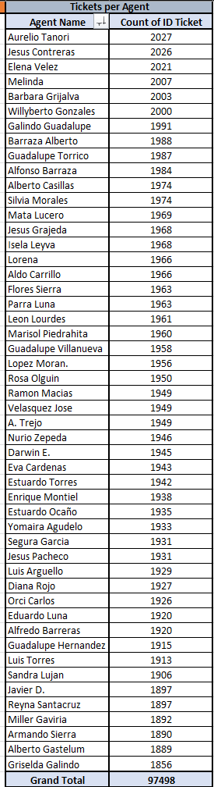
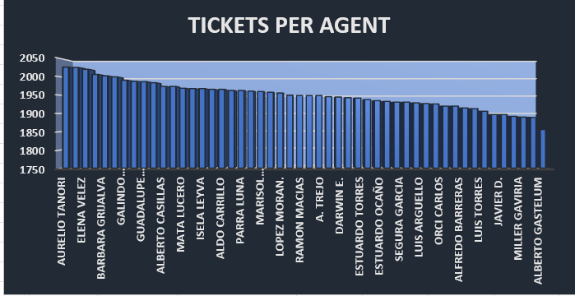
Displays ticket handling count by each agent.
Question 6: How can you extract the domain from the email addresses in the IT Agents sheet?
Solution:

Final Answer:
The final result is ‘fp20analytics’.

Approach:

Charts & Tables:
- Table / Chart Name:
Email Domain Extraction
- Description:
Displays extracted domain names from agent email addresses.
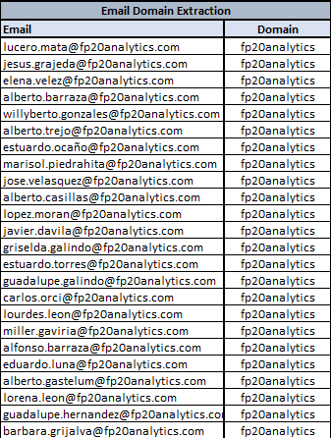

Question 7: How can you find the full name of an agent given their Agent ID?
Solution:

Final Answer:
Full Name of an agent is extracted by their respective agent ID by using XLOOKUP formula
=XLOOKUP([@[Agent ID]],IT_Agents6[Agent ID],IT_Agents6[Full Name])

Approach:
Used XLOOKUP to map Agent ID with corresponding Agent Name.

Charts & Tables: mentioned in ‘Tickets (cleaned Data)’ sheet.
- Description:
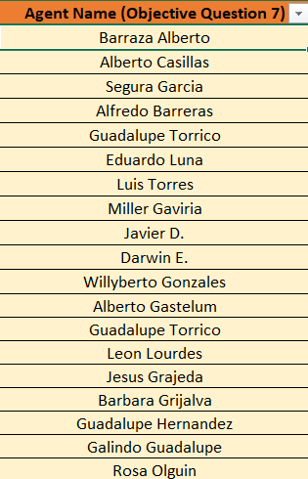
Displays full agent name based on Agent ID.

Question 8: What is the count of each issue type (e.g., IT Error, IT Request)?
Solution:

Final Answer:
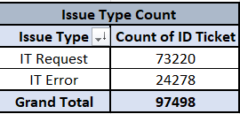
Approach:
A Pivot table is created with
- Rows → Issue type
- Values → Count of ID Ticket
Count of ID Ticket is sorted from largest to smallest. Two charts (Pie chart and Column chart) are prepared shown in the image.

Charts & Tables:
- Table / Chart Name:
Issue Type Count
- Description:
Displays number of tickets by issue type.

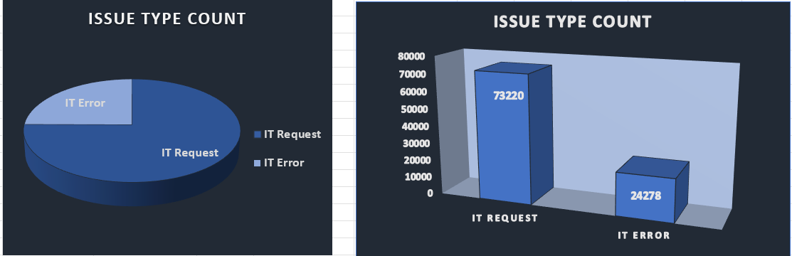

Question 9: What is the daily average resolution time for tickets?
Solution:

Final Answer:
The average ticket resolution time is 4.55 days.
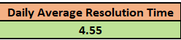

Approach:
A Pivot table is created with
- Rows → Date
- Values → Average of Resolution Time (Days)
Daily average resolution time for tickets is calculated using this formula =AVERAGE(D7:D1833) to get average of approximately 4.55 days of daily resolution time.

Charts & Tables:
- Table / Chart Name:
Daily Average Resolution Time
- Description:
Displays daily average resolution time for tickets.
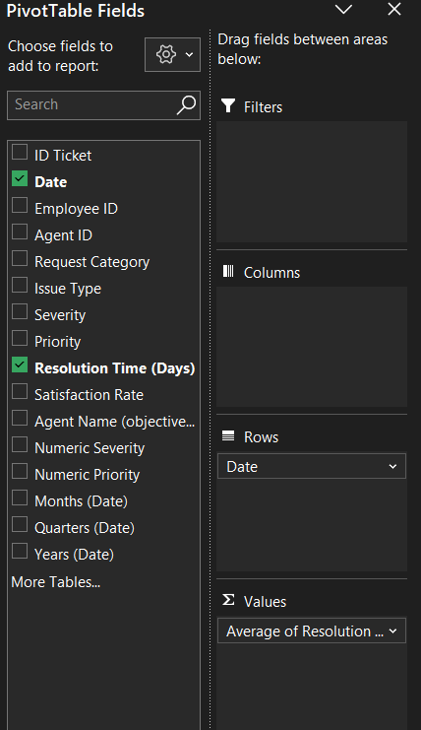
Question 10: How has the volume of tickets changed over time?
Solution:

Final Answer:
Volume of tickets has gone in an upward trend over time.
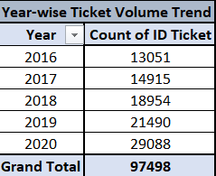
Approach:
A pivot table is created using:
Rows → Date (grouped by year)
Values → Count of ID Ticket

Charts & Tables:
- Table / Chart Name:
Year-wise Ticket Volume Trend
- Description:
Displays trend in ticket volume over time.

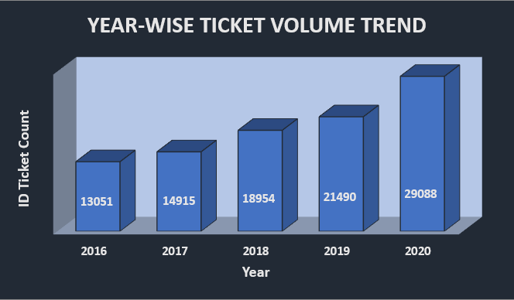
Question 11: What is the average age of the IT agents?
Solution:

Final Answer:
Average age of IT Agents is approximately 41 years.

Approach:
Year of Birth, Month of Birth, Day of Birth column is copied in ‘Q11 | Objective’ sheet.
Then from these column DOB was calculated using =DATE(I7:I56,J7:J56,K7:K56).
Then individual age was calculated using =DATEDIF(L7:L56,TODAY(),"Y").
Then average of IT Agents is calculated using =AVERAGE(M7:M56) to have average of 40.6 (approximately 41 years of age).

Charts & Tables:
- Table / Chart Name:
Average Age Calculation
- Description:
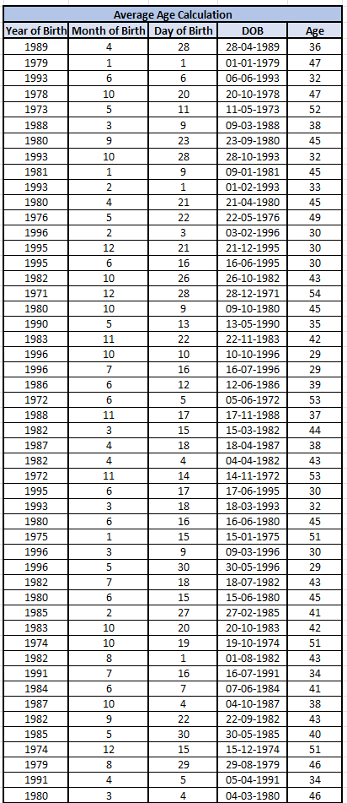
Displays calculated ages of all IT agents.

Question 12: Is there a correlation between the severity of issues and the resolution time?
Solution:

Final Answer:
Correlation between the severity of issues and the resolution time is -0.040536349.

Approach:
To calculate correlation between two factors, numerical arrays were needed, so severity which was in the ‘0 – Unclassified’ form converted to numerical severity by using Test-to-column feature of Data tools, then numerical severity array and resolution time array was put into this formula =CORREL($D$7:$D$97504,$E$7:$E$97504), here column D is numeric severity and column E is resolution time.

Charts & Tables:
- Table / Chart Name:
Correlation Calculation
- Description:
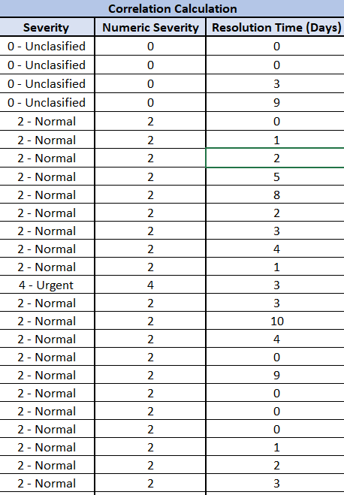
Displays relationship between severity level and resolution time. Since very weak negative correlation is found between severity and resolution time, there is no meaningful relationship between severity of issues and resolution time.
Question 13: How many categorical columns are there in the data? [Search about categorical and continuous data, and try to answer this question]
Solution:

Final Answer:
Total number of categorical columns in Cleaned Data (Tickets and IT Agents) are 12.

Approach:
- A rule was set to identify categorical columns. Rule for categorizing columns into categorical data and continuous data:
- Categorical data - Data that contains unique identifiers (both categorically and numerically unique).
- Continuous data - Data that has measurable numeric quantity and are not unique identifiers.
- Categorical columns are identified using below mentioned method:
- A helper table was created having column name and above mentioned rule was used to categorize each column. Data Validation feature was used and validation criteria was given to have Categorical and Continuous dropdown. Conditional Formatting feature was used to highlight 'Categorical in Green' and 'Continuous in Red' fill and colour. Then count of categorical columns was calculated using this formula:
=COUNTIF(C6:D26,"Categorical")

Charts & Tables:
- Table / Chart Name:
Categorical Column Identification (sheet - Q13 | Objective)
- Description:
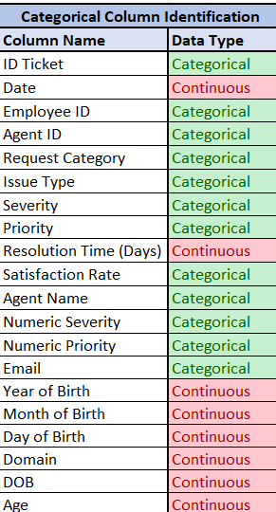
Displays classification of dataset attributes into categorical and continuous.

SUBJECTIVE QUESTIONS

Question 1: If there is an investment, should it be used to hire more IT agents, improve training programs, or upgrade ticket management software?
Analysis: Perform a cost-benefit analysis using ticket resolution and satisfaction metrics.

Solution:

Approach:
Three pivot tables are created naming Agent Performance Summary, Year-wise Performance Summary and Category-wise Performance Summary. Metrics like ID ticket count, average satisfaction rate and average resolution time (days) are used to analyse the performance. Agent-wise, Year-wise and Category-wise performance was evaluated over three parameters:
(1) Average resolution time = approx. 4.55 (High)
(2) Average satisfaction rate = approx. 4.1 (Decent)
(3) Total ID Ticket = 97498 | Number of Agents = 50 | Average ID ticket per agent = 1950 (Stable).

Charts & Tables:
1. Table Name: Agent Performance Summary
- Description:
Displays the number of tickets handled by each agent along with their average satisfaction rate and average resolution time. It helps evaluate agent efficiency and identify top and underperforming agents. Agent's metrics are highlighted with red colour in the pivot table for particular agent that needs further training.
2. Table Name: Year-wise Performance Summary
- Description:
Displays the yearly trend of ticket volume, average satisfaction rate and average resolution time from 2016 to 2020. It helps in understanding workload growth and overall service performance over time.

3. Table Name: Category-wise Performance Summary
- Description:
Shows the count of tickets, average satisfaction rate and average resolution time for each request categories such as Hardware, Software, System, and Login Access. It helps identify which categories take longer to resolve and require improvement. Category is sorted from largest to smallest with respect to ID ticket count.
4. Chart Name: Agent Performance Summary
- Description:
A custom combination chart is prepared with Count of ID Ticket as Clustered column chart on secondary axis; Average of satisfaction rate and Average resolution time (days) as Line with markers chart to identify each agent’s performance.
5. Chart Name: Year-wise Performance Summary
- Description:
A custom combination chart is prepared with Count of ID Ticket as Clustered column chart on secondary axis; Average of satisfaction rate and Average resolution time (days) as Line with markers chart to identify IT support performance over the years.
6. Chart Name: Category-wise Performance Summary
- Description:
A custom combination chart is prepared with Count of ID Ticket as Clustered column chart on secondary axis; Average of satisfaction rate and Average resolution time (days) as Line with markers chart to identify IT support performance across different request categories.

Insights:
- Ticket volume has increased significantly over years from 13051 in year 2016 to 29088 in year 2020.
- Satisfaction Rate has improved slightly over the years from 3.98 in year 2016 to 4.16 in year 2020.
- Resolution time has not decreased over the years instead gone up which is a concerning factor.
- Request categories like Hardware, System and Software has higher resolution time.
- Average ID Ticket Count per Agent is 1950 tickets.

Recommendations:
- Resolution time can be reduced by upgrading ticket management system, improving technology in resolving Hardware, Software and System requests.
- Hire more IT Agents as ticket volume has increased significantly over time, indicating sharp increase in workload.
- Underperforming Agents needs parameter specific trainings to improve in the area they are lacking.
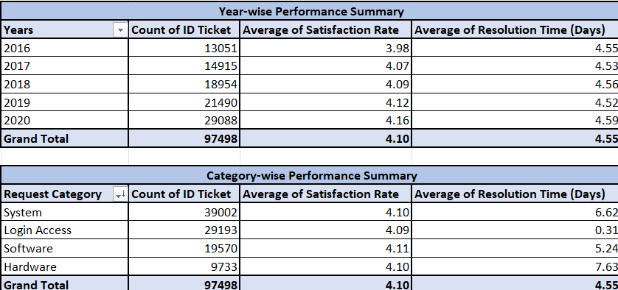
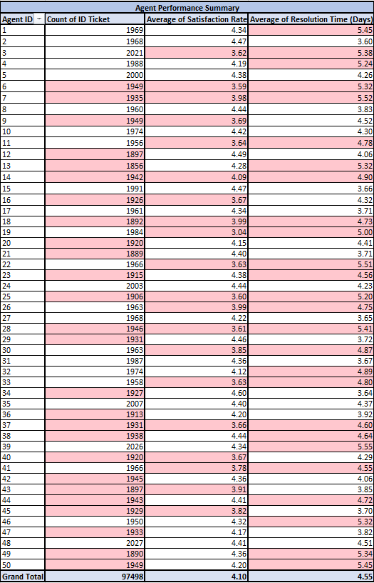
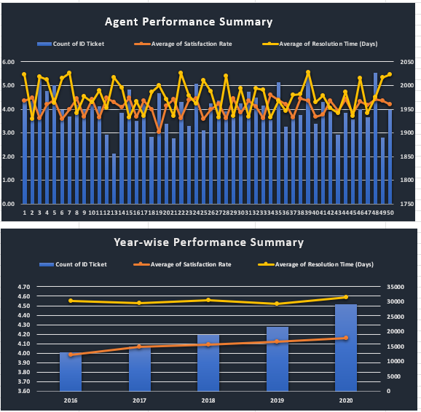
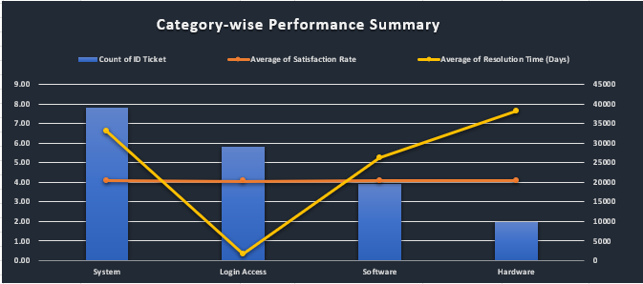
Question 2: Which agents need additional training based on their performance metrics?
Analysis: Identify agents with the lowest satisfaction ratings and longest resolution times.

Solution:

Approach:
To analyse which agents need additional training, two pivot tables are created. One table based on average satisfaction and another table for average resolution time (days) to identify lowest performing agent.

Charts & Tables:
1. Table Name: Low performing agents w.r.t. satisfaction rate
- Description: Displays agents with their respective average satisfaction rate and sorted it from smallest to largest. Also, agent’s satisfaction rating that have less than total average value of 4.1 are highlighted. It is sorted smallest to largest because low performing agent’s metrics will be below overall average.
2. Table Name: Low performing agents w.r.t. resolution time (days)
- Description: Displays agents with their respective average resolution time and sorted it from largest to smallest. Also, agent’s metrics (resolution time) that have greater than average value of 4.55 are highlighted. It is sorted largest to smallest because low performing agent’s metrics will be above overall average.

Insights:
- Agents that have satisfaction rate less than average value of 4.1 are highlighted using below average rule of conditional formatting.
- Agents that have resolution time greater than average value of 4.55 are highlighted using above average rule of conditional formatting.
- Lowest performing agents are Alfonso Barraza, A. Trejo, Sandra Lujan, Nurio Zepeda, Elena Velez, Lorena, Guadalupe Villanueva, Lopez Moran, Jesus Pacheco, Aldo Carrillo, Parra Luna, Estuardo Ocaño, Flores Sierra, Miller Gaviria and Estuardo Torres because they occurring in both the tables having lower satisfaction rate and higher resolution time indicates inadequate performance and inability to support and handle employee’s IT issues.
- Agents that occur in both the tables are highlighted using highlight duplicate values feature of conditional formatting with yellow fill and text colour.

Recommendations:
- Provide immediate targeted re-training for these agents.
- Assign simpler tickets temporarily.
- Encourage knowledge sharing from top-performing agents.
- Monitor performance regularly using key metrics.
- If no improvement is shown, replace them, as keeping consistently low performers drags system-wide efficiency.
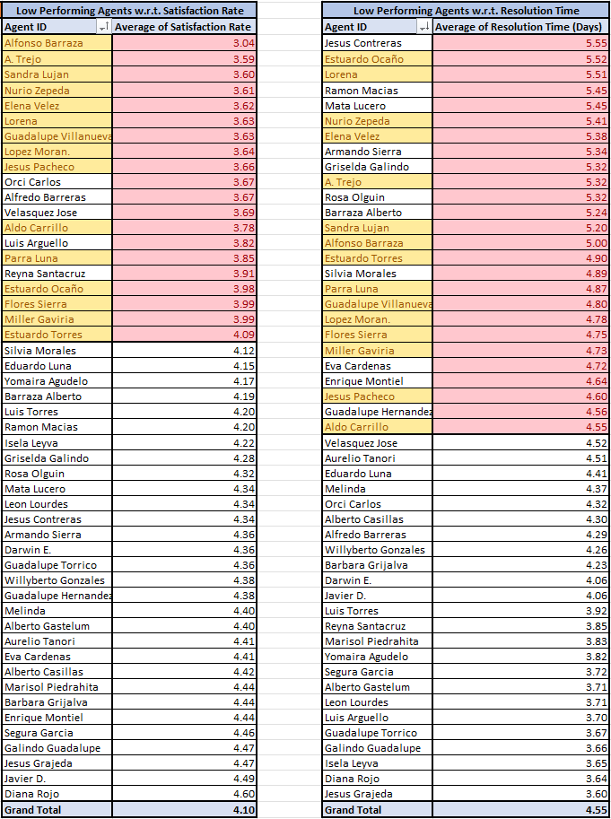
Question 3: Do certain categories of requests have longer resolution times?
Analysis: Analyse the resolution times by request category.

Solution:

Approach:
A pivot table is created with request category in rows and average of resolution time (days) in values to calculate average of resolution time of each category. Sorted it in largest to smallest by average of resolution time (days).

Charts & Tables:
- Table Name:
Resolution Time by Category
- Description:
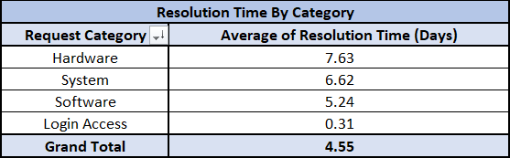
Displays the average resolution time (days) for each request category to identify which category took longer time to get resolved.

- Chart Name:
Resolution Time by Category
- Description:
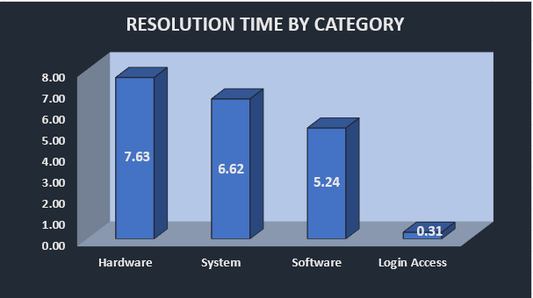
A 3D clustered column chart comparing average resolution time for categories like Hardware, System, Software and Login Access.
Insights:
- Overall average resolution time (days) is 4.55 days.
- Hardware, System and Software requests have longer resolution time.
- Hardware requests have the highest average resolution time of approx. 7.63 days.
- System requests too have high resolution time of approx. 6.62 days, but it is lower than hardware requests.
- Software requests took longer time to get resolved of approx. 5.24 days; it is lower than hardware and system requests in comparison but yet higher than the overall average resolution time of 4.55 days.
- Login Access requests were resolved within the same day as its average resolution time is approx. 0.31 days.
- This indicates that complex request categories take significantly longer time to get resolved.

Recommendations:
- Provide specialized training for complex issue categories.
- Create specialized teams for Hardware & System issues.
- Pre-diagnosis automation before ticket assignment.
- Automate simple requests like Login Access.
- Assign experienced agents to high-resolution-time categories.
- Introduce priority escalation workflows.

Question 4: How effective are the current software tools in managing IT tickets?
Analysis: Evaluate performance metrics before and after the implementation of new tools.

Solution:

Approach:
The category-wise tools analysis is evaluated over time by creating a pivot table using request category in rows, years in columns and average of resolution time (days), average of satisfaction rate and count of ID Ticket in values.

Charts & Tables:
- Table Name:
Category wise tools analysis over time
- Description:
Displays comparison of category-wise satisfaction score and resolution time alongside count of tickets over time.
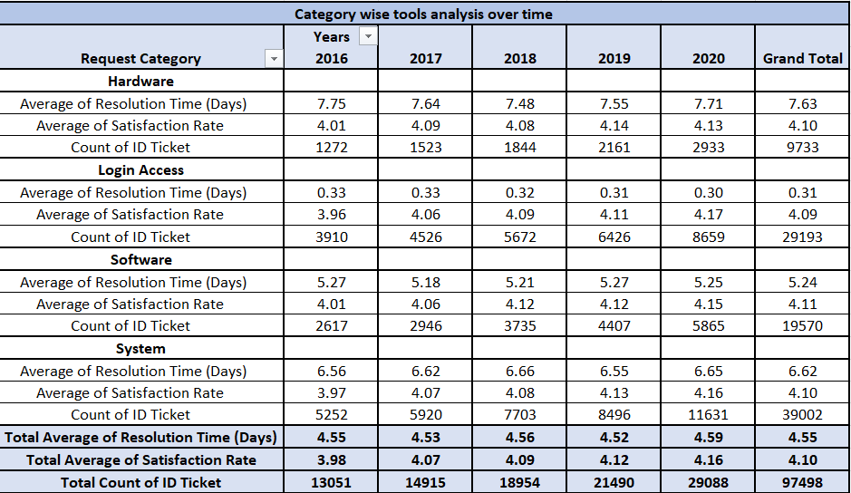

Insights:
- Ticket volume increased significantly from 2016 to 2020.
- Satisfaction improved slightly but is marginal indicating efficiency has not improved.
- Resolution time remains high; hence tools are not efficient enough.
- System lacks automation for complex workflows.
- Current software tools are not effective in managing IT tickets.
Recommendations:
- Upgrade ticket management tools.
- Implement automation and intelligent routing to further improve efficiency.
- Improve tracking and monitoring capabilities.
- Provide training for better tool utilization.
Question 5: How has the performance of the IT support team changed over time (e.g., monthly or quarterly)?
Analysis: Trend analysis using time series charts.

Solution:

Approach:
A pivot table is created with Quarters (Date) and Months (Date) in rows and Count of ID ticket and Average of resolution time (days) in values to analyse trends using time series data.

Charts & Tables:
- Table / Chart Name:
Performance of IT Team over time
- Description:
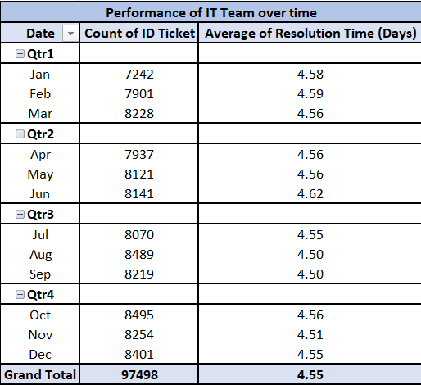
Displays increase in tickets over time yet the average resolution time (days) remains stagnant. Two images are shown here in which image 1 is showing monthly data and image 2 is showing quarterly data.
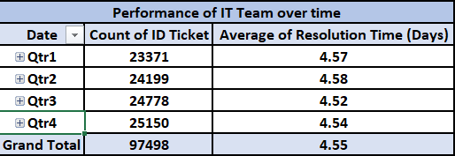
- Chart Name:
Performance over time
- Description:
A custom combination chart with count of ID Ticket as a clustered column chart and Average of resolution time (days) as a line with markers chart on secondary axis to identify performance trend over time. Two images are shown, first showing monthly performance over time and second image showing quarterly performance over time.
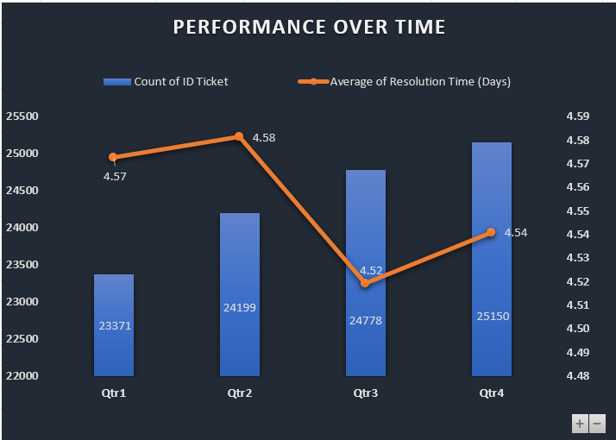
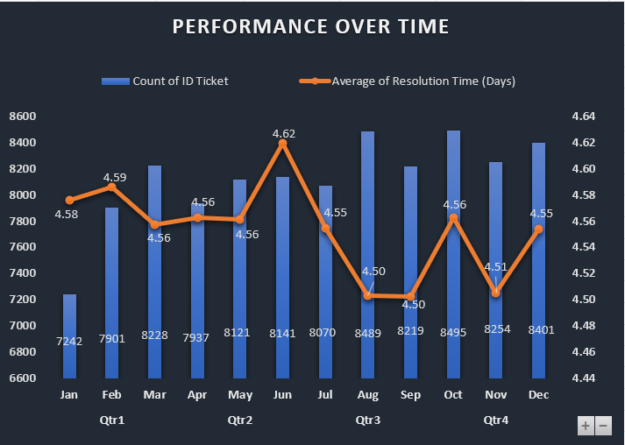

Insights:
- Ticket volume is constantly rising every quarter.
- Resolution Time remains stable but constantly high.

Recommendations:
- Focus on efficiency improvements.
- Scale processes along with demand growth.
- Operational efficiency has not improved over time, needs training.

Question 6: If we invest more on tech (Hardware, software, etc), do you think it will improve the ticket resolution times and employee satisfaction?
Analysis: Use historical data to project potential improvements.

Solution:

Approach:
Two pivot tables are created
- With request category in rows and average resolution time (days) and average satisfaction rate in values and sorted it largest to smallest by average of resolution time (days).
- With request category in rows and count of ID ticket in values and sorted it largest to smallest by count of ID ticket.

Charts & Tables:
1. Table Name:
Category-wise Performance
- Description:
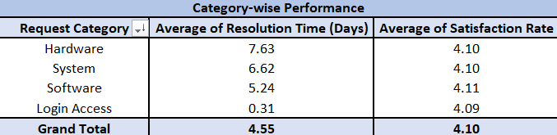
Displays average resolution time (days) and average of satisfaction rate across different request categories.

2. Table Name:
Category-wise Ticket Count
- Description:
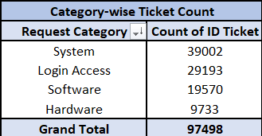
Displays ID ticket count across different categories.

3. Chart Name:
Category-wise Performance
- Description:
A 3D-clustered column chart is prepared showing performance across different request categories.

4. Chart Name:
Category-wise Ticket count
- Description:
A 3D-clustered column chart is prepared showing ticket count for each request category.
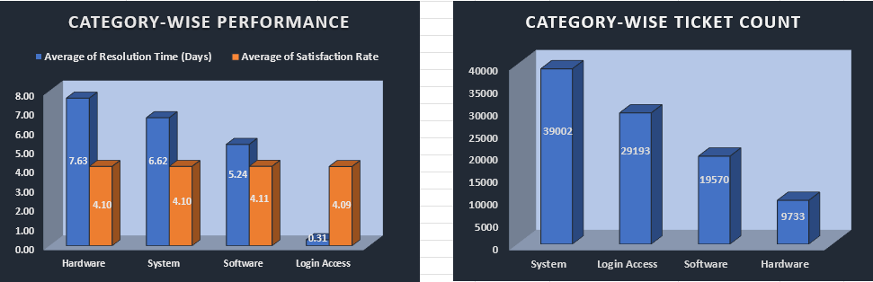
Insights:
- Hardware requests have highest number of average 7.63 resolution days.
- System requests have slight lesser but still high of average 6.62 resolution days.
- Software requests have approx. 5.24 resolution days.
- Minor portion of ticket count for hardware and software-based IT problems are taking highest number of resolution days.

Recommendations:
- Technology investment will directly improve efficiency and satisfaction.
- Upgraded tech can reduce resolution time.
- Investing in technology can improve resolution times as it will directly impact the lesser number of hardware and software requests.
- Invest in automation, AI-based ticket routing, self-service systems.
- Improving and investing in system tools can tackle the wide ticket count and higher resolution days for system requests.
- Maintain current service quality to keep satisfaction levels high.
Question 7: What are the key performance metrics for IT agents, and how can they be improved, do we need to fire any agents?
Analysis: Define and analyse metrics such as average handling time, satisfaction scores, and number of tickets resolved.

Solution:

Approach:
- A pivot table is created to analyse individual agent’s performance using metrics such as average of resolution time (days), average of satisfaction rate and count of ID ticket. Each metric is assessed according to their overall average value.
- Average of resolution days is sorted ‘largest to smallest’ to get the value of individual agent higher than the overall average value of 4.55 days.
- Average of satisfaction rate is sorted ‘smallest to largest’ to get the value of individual agent lower than the overall value of 4.1 ratings.
- Count of ID ticket is averaged using this formula =AVERAGE(F7:F56) to have 1950 average ticket count. And then sorted ‘smallest to largest’ to get the value of individual agent lower than 1950 tickets.
- Such individuals are identified and three helper table are created.
- Agents name that are repeated in all three helper tables are highlighted using highlight duplicate values feature of conditional formatting.

Charts & Tables:
1.Table Name:
Agent Performance Metrics
- Description:
Pivot table that displays key performance indicators (KPIs) for each agent.
2. Table Name:
Low Performing Agent (Resolution Time)
- Description:
A helper table that displays all the low performing agents based on average resolution time.
3. Table Name:
Low Performing Agent (Satisfaction Rate)
- Description:
A helper table that displays all the low performing agents based on average satisfaction rate.
4. Table Name:
Low Performing Agent (Ticket Count)
- Description:
A helper table that displays all the low performing agents based on average
Ticket count.

Insights:
- Key performance indicators (KPIs) for IT Agents are:
- Average resolution time
- Average satisfaction rate
- Count of ID ticket for individual agents.
- Agents that are performing lower than the average are as follows:

Alfonso Barraza, A. Trejo, Sandra Lujan, Nurio Zepeda, Elena Velez, Lorena, Guadalupe Villanueva, Lopez Moran, Jesus Pacheco, Orci Carlos, Alfredo Barreras. Luis Arguello, Parra Luna, Reyna Santacruz, Estuardo Ocaño, Flores Sierra, Miller Gaviria, Estuardo Torres.

Recommendations:
- Immediate termination is not advised.
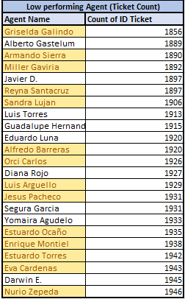
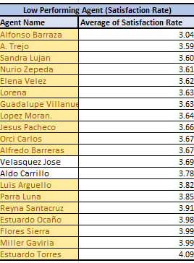
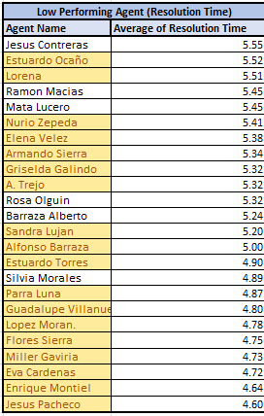
- Training intervention should be attempted before workforce reduction decisions.
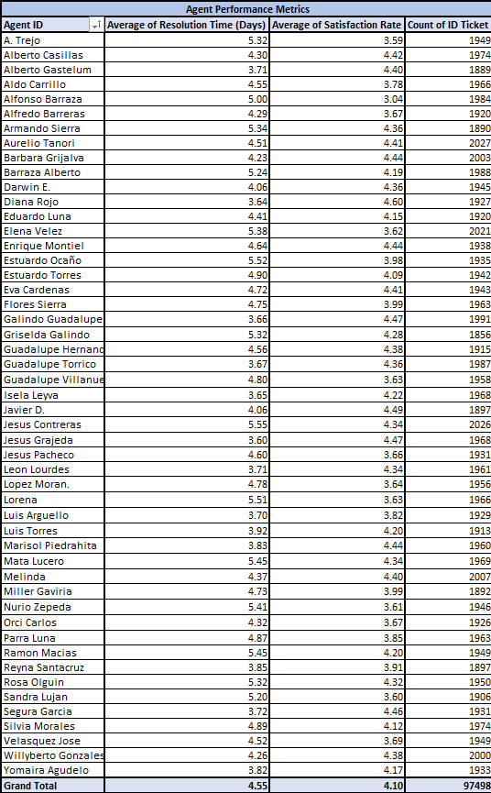

Question 8: How do employee demographics (e.g., department, seniority) impact satisfaction and ticket outcomes?
Analysis: Segment analysis using filters and pivot tables.

Solution:

Approach:
A pivot table is created using age in rows and average satisfaction rate and average resolution time (days) in values to analyse performance based on senority.

Charts & Tables:
- Table Name:
Performance based on Age group (Seniority)
- Description:
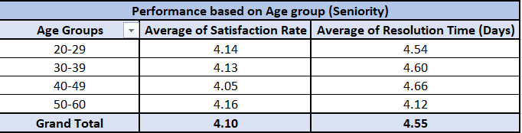
Displays performance by age groups.

- Chart Name:
Performance by Seniority
- Description:
A 3D clustered column chart is created showing performance by different age groups.

Insights:
- All the age groups have high resolution time.
- Satisfaction rate among all the age groups are more or less similar.
- Senior most age group (50-60) shows comparatively lesser resolution time than other age groups.
- Performance variance is skill-based, not demographic-based.

Recommendations:
- Assign experienced employees to handle critical issues.
- Hiring decisions should NOT rely on demographics.
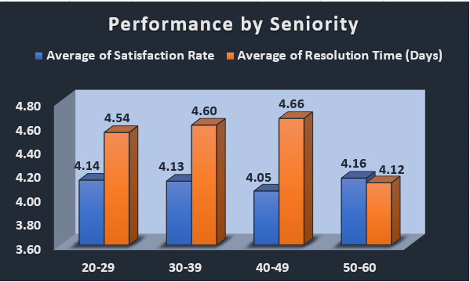

Question 9: Identify the trends for IT support operations based on ticket volumes and satisfaction, and mention the peak and stable times?
Analysis: Use pivot tables and charts to identify peak and off-peak hours.

Solution:

Approach:
A pivot table is created using Years (Date) and Months (Date) in rows and Average of satisfaction rate and Count of ID Ticket in values to identify trends for IT support and analyse the peak and off-peak times.

Charts & Tables:
- Table Name:
Ticket Volume and Satisfaction Trend
- Description:
This table displays the variation in ticket volume and satisfaction rate over different years and months, helping to identify peak and stable operational periods.

- Chart Name:
Ticket Volume and Satisfaction Trend
- Description:
A custom combination chart is prepared with average satisfaction rate as stacked column chart and count of ID ticket as line with markers chart on secondary axis to identify ticket volume and satisfaction trend.

Insights:
- Ticket Volume is constantly in an increasing trend over the years, but dips in January.
- Satisfaction rate is also in an increasing trend over the years, but rises significantly in January when compared to rest of the year.
- Peak times for IT Ticket volume - Peak month for each year is highlighted with yellow colour.
- Stable times for IT Ticket volume - Unhighlighted months are off-peak times.
- Peak times for Satisfaction rate - Peak month for each year is highlighted with green colour.
- Stable times for Satisfaction rate - Unhighlighted months are off-peak times.

Recommendations:
- Stable periods can be used for training and system upgrades
- Prepare for peak load scaling by increasing staff and resource allocation to handle high ticket volume.
- Maintain consistent service quality even during high workload periods.
- Use trend analysis for future planning and forecasting.
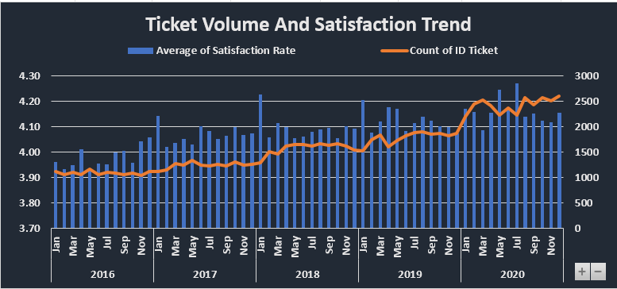
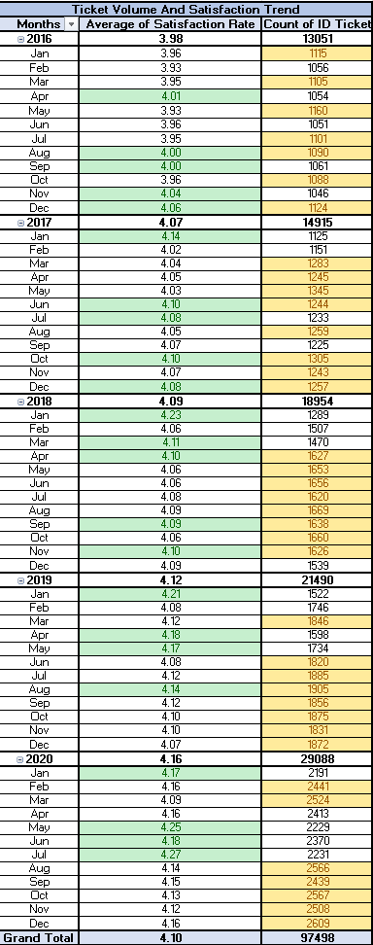

Question 10: What metrics should be included in the final dashboard to provide a comprehensive view of call centre performance and guide investment decisions?

Solution:

Approach:
To design an automated dashboard, key metrics such as ticket volume, resolution time and satisfaction rate helped in getting total ticket volume, total agents, daily average ticket volume, ID ticket count per agent, efficiency and agent performance.

Charts & Tables:
- Table / Chart Name:
IT Support Performance and Ticket Analysis Dashboard
- Description:
The dashboard displays a consolidated and automated view of IT support performance that includes analysis of ticket volume trends, resolution time in days, satisfaction ratings, category-wise performance and individual agent’s performance using multiple charts, key metrics and connected slicers.

Insights:
- Ticket volume has increased significantly over time (2016-2020) indicating high demand for IT support.
- Average satisfaction rate has improved slightly over the years but not exponentially.
- Average resolution time has remained stagnantly high over the years.
- Despite having comparatively lesser number of tickets for Hardware, Software categories, they take higher resolution time to get resolved.
- System category requests have higher ticket volume as well as higher resolution time.
- Login access request has approx. 30% ticket volume but they are resolved quickly on same day with high satisfaction rate.
- Many agents perform better than others with higher satisfaction rate and lesser resolution time.
- Severity does not have an inverse impact on resolution time, in fact Urgent severity took on an average 2.00 days get resolved while Normal severity took 4.66 days to get resolved.
The final dashboard includes:
- Total ticket volume: 97498 tickets.
- Total agent / Agent ID: 50 total agents (Agent’s ID will display when clicked on any agent’s name from agent name slicer).
- Average resolution time: 4.55 days.
- Average Satisfaction rate: 4.1 out of 5 rating points.
- Daily Average ticket volume: 53.37 tickets.
- Average Ticket count per agent: approx.1950 tickets.
- Count of tickets by time.
- Count of tickets by request category.
- Satisfaction rate by time.
- Average resolution time by request category, quarter-wise.
- Age group by satisfaction rate.
- Ticket by severity rate.
- Distribution of tickets based on satisfaction score.
- Distribution of tickets based on Resolution time.
- Interactive slicers - Request Category, Severity, Satisfaction Rate, Years (Date), Agent Name, Resolution Time (Days)
- Slicers are connected to all the tables and chart used for dashboard.

Recommendations:
- Underperforming agents dragging results down, provide metric based training.
- Improve the inefficiency by investing in tech upgrades to reduce resolution time for hardware, system and software categories.
- Implementing self-service and automated workflows for repetitive tasks like login access.
- Hire more agents as ticket volume has gone more than double from 2016 to 2020.
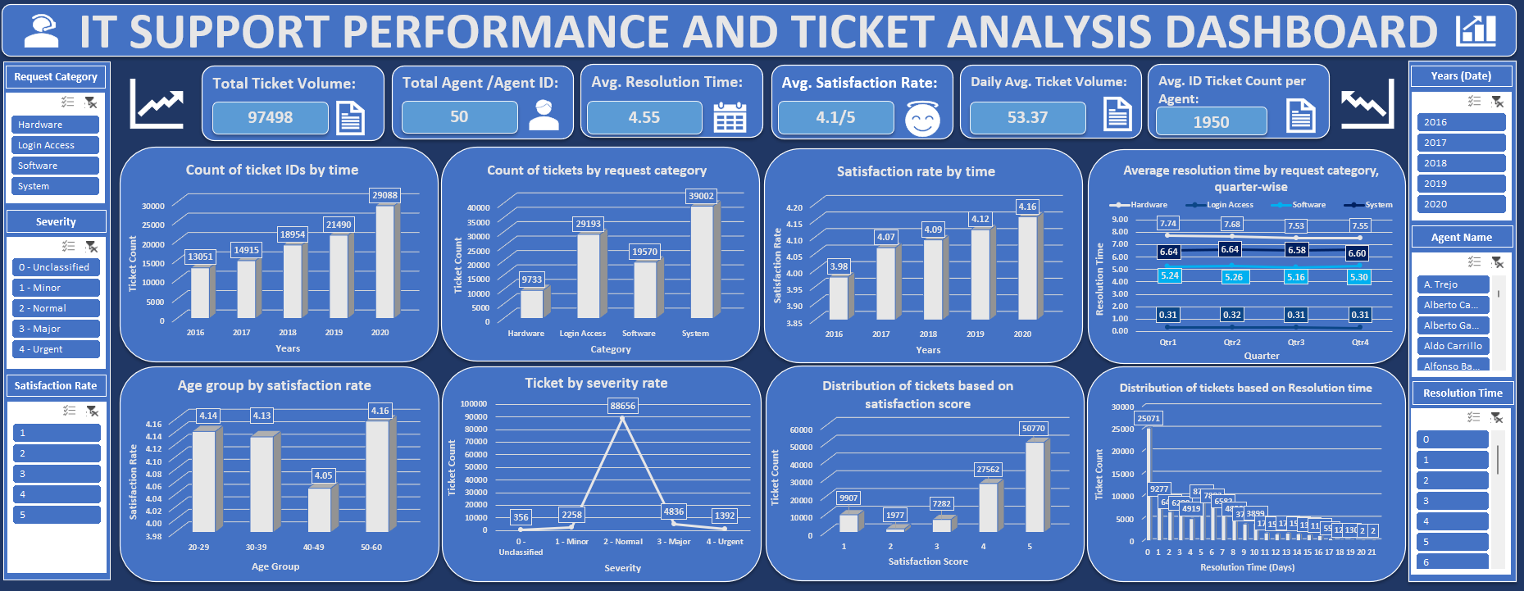
- Without tech upgrades and performance enforcement, this system will not scale.

